PROJECT BASED LEARNING REPORT

ON

**SOLAR POWER SYSTEM REVIEW USING MATLAB**

**SIMULATION**

**SUBMITTED TO THE**

SAVITRIBAI PHULE PUNE UNIVERSITY

**SECOND YEAR OF ELECTRONICS AND TELECOMMUNICATION ENGINEERING**



**SUBMITTED BY: -**

Mr. Prasad Nikam

Mr.Pranav Kolekar

Ms. Ashlesha Parab

Mr. Anuj Sabade

**UNDER THE GUIDANCE OF: -**

**Prof. Sunil Pansare**

**DEPARTMENT OF ELECTRONICS & TELECOMMUNICATION ENGINEERING**

**MODERN EDUCATION SOCIETY’S COLLEGE OF ENGINEERING PUNE-411001**

**[2022-2023]**

**SAVITRIBAI PHULE PUNE UNIVERSITY**

MODERN EDUCATION SOCIETY’S COLLEGE OF ENGINEERING PUNE-411001

Department of Electronics & Telecommunication Engineering



**C E R T I F I C A T E**

This is to certified that the Project Based Learning entitled “SOLAR SYSTEM REVIEW” has been submitted by,

## Mr. Pranav Kolekar

**Mr. Prasad Nikam**

**Ms. Ashlehsa Parab-**

**Mr. Anuj Sabade**

As a partial fulfillment for the Bachelor of Engineering degree in Electronics &

Telecommunication of Savitribai Phule Pune University during the academic year 2022-2023.

Date:

Place: Pune

Project Guide Head of Department

**Prof. S. S. Pansare** **Dr. P. P. ManeINDEX**

|  |  |
| --- | --- |
| 1. | Acknowledgement |
| 2. | Abstract |
| 3. | Introduction |
| 4. | Types Of Solar System |
| 5. | Construction |
| 6. | Working |
| 7. | Solar Panel Sizes |
| 8 | MATLAB Simulation |
| 9. | Waveforms |
| 10. | Tools Used For Simulation |
| 11. | Resources |
| 12. | Calculations |
| 13. | Conclusion |

**ACKNOWLEDGEMENT**

Ability and ambition are not enough for success. Many able people fail to achieve anything worthwhile because he or she has not been properly guided and directed. The project on ***“SOLAR SYSTEM REVIEW”*** is an outcome of guidance, moral support & devotion bestowed on us throughout our work. First and foremost, I offer our sincere phrases of thanks to **Prof. S. S. Pansare Sir** for their guidance and constant supervision as well as for providing necessary information during seminar preparation. We express our gratitude to **Dr. P.P. Mane**, Head of E&TC department for their kind co-operation.

Finally, I would like to express my gratitude towards my parents & and all teaching and non-teaching staff members of E&TC department for their kind co-operation and encouragement which help us in completion of this project.

Thanking you,

Mr. Prasad Nikam

Mr.Pranav Kolekar

Ms. Ashlesha Parab

Mr. Anuj Sabade

**(SE E&TC Engineering)**

**E&TC-B**

**ABSTRACT**

The Solar Power System Review project aims to provide a comprehensive overview of solar power systems, including their types, construction, working, and market available sizes of solar panels. The project explores the three main types of solar power systems, including grid-tied, off-grid, and hybrid systems.

The project analyses the construction process of solar power systems, including the components involved such as solar panels, inverters, and batteries. The technical working of solar power systems is also explained, including the conversion of solar energy into electrical energy.

Furthermore, the project covers the market available sizes of solar panels, their efficiency, and the factors to consider when selecting solar panels. The report aims to provide valuable insights into the benefits of solar power systems, including their cost savings, environmental impact, and reliability.

Overall, this project aims to provide a comprehensive and informative resource for individuals and businesses interested in transitioning to renewable energy sources and making informed decisions regarding solar power systems.

**1.Introduction**

A solar power system is a type of renewable energy technology that converts sunlight into electrical energy. It typically consists of a series of solar panels, which are composed of photovoltaic cells that convert sunlight into direct current (DC) electricity. This DC electricity is then converted into alternating current (AC) electricity using an inverter, which can be used to power homes, businesses, and other buildings.

A solar power system can be installed on a rooftop, on the ground, or on a tracking device that follows the path of the sun throughout the day. The amount of electricity generated by a solar power system depends on factors such as the size and efficiency of the solar panels, the amount of sunlight available in the location, and the angle and orientation of the panels. Solar power systems are becoming increasingly popular as a clean and sustainable source of energy, and can help reduce dependence on fossil fuels and lower greenhouse gas emissions.

Solar panels are the primary component of a solar power system. They are made up of photovoltaic (PV) cells, which are responsible for converting sunlight into direct current (DC) electricity. PV cells are made of semiconducting materials such as silicon, and they work by absorbing photons from sunlight, which excites electrons and generates a flow of electricity. The size and number of solar panels required for a solar power system depend on the amount of energy needed and the available sunlight in the area.

Solar power systems also have minimal maintenance requirements, making them a hassle-free choice for energy generation. The solar panels themselves require little maintenance and can last for up to 25 years or more. The other components of the system, such as the inverter and batteries, may need occasional maintenance or replacement, but overall, solar power systems are much less demanding than traditional energy sources. With the benefits of environmental friendliness, cost savings, and minimal maintenance, solar power systems are an excellent choice for those looking for a sustainable energy source.

A solar power system is an excellent alternative to traditional energy sources. Unlike fossil fuels, which are finite and non-renewable, solar power relies on the energy of the sun, which is abundant and sustainable. Solar panels can generate electricity in areas with plenty of sunlight, making them an ideal choice for many regions around the world. In addition to being an environmentally friendly option, solar power can also save money in the long run. While the initial installation cost may be higher than traditional energy sources, the ongoing cost of operation and maintenance is much lower, and the system can pay for itself over time.

**2.Types of Solar System**

When discussing solar systems, there are typically three main categories to consider: on-grid, off-grid, and hybrid systems. Here's a brief review of each

1. Grid-tied/On-grid solar system:

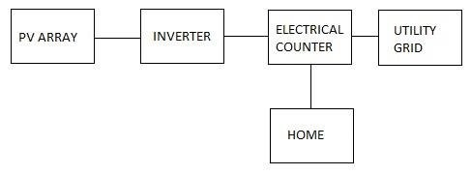Grid-tied or On-grid solar power systems are the most common type of solar power system. These systems are connected to the electrical grid, which allows excess electricity generated by the solar panels to be sold back to the utility company, resulting in credits on the homeowner's energy bill. This type of system does not typically require batteries, as the grid serves as a backup power source during periods of low sunlight. Grid-tied systems are generally less expensive than off-grid systems, and they are an excellent option for homeowners who want to reduce their energy costs while still remaining connected to the grid.

1. Off-grid solar system:

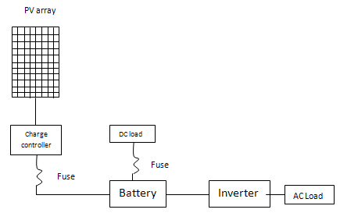Off-grid solar power systems are not connected to the electrical grid and rely on batteries to store excess energy for use at night or during periods of low sunlight. This type of system is more expensive than On-grid systems, as it requires additional components such as batteries and charge controllers. However, off-grid systems are an excellent option for those who live in remote areas without access to the electrical grid or for those who want to live off the grid entirely. These systems require careful planning to ensure that they generate enough electricity to meet the household's energy needs.

1. Hybrid solar system:

As the name suggests, these systems combine elements of both on-grid and off-grid systems. They typically include both solar panels and battery storage, allowing homeowners to use solar energy during the day and store excess energy for use at night or during power outages. Hybrid systems are often used in areas with unreliable grid access, as they provide a backup power source in case of outages.

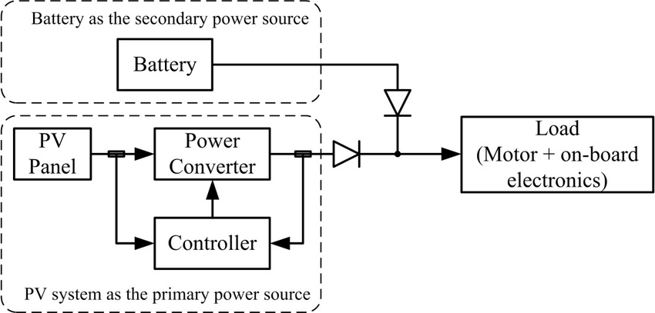The battery backup system in a hybrid solar power system is typically made up of deep-cycle batteries that store excess energy generated by the solar panels. When the solar panels are not generating enough electricity to meet the household's energy needs, power is drawn from the batteries. The battery backup system provides a reliable source of power during power outages or other situations where the electrical grid is not available. Hybrid solar power systems also typically include a charge controller, which regulates the flow of electricity between the solar panels, battery backup system, and the grid. The charge controller ensures that the batteries are charged efficiently and prevents them from overcharging or discharging.

Each type of solar system has its own advantages and disadvantages, depending on the specific needs of the homeowner. On-grid systems are typically the most cost-effective option, as they don't require expensive battery storage. Off-grid systems, on the other hand, offer complete energy independence but are generally more expensive to install and maintain. Hybrid systems offer a balance between the two, providing backup power while still allowing homeowners to take advantage of grid-connected benefits.

**3.Construction**

**The construction of a solar power system varies depending on the type of system.**

1. Grid-tied or On-grid solar power system construction:

The construction of an on-grid or grid-tied solar power system typically involves the following components:

* Solar panels
* Inverter
* Mounting system
* Electrical equipment

The solar panels are mounted on a sturdy structure using a mounting system, and the DC electricity generated by the solar panels is converted into AC electricity using an inverter. The AC electricity is then distributed throughout the building using electrical equipment such as breakers, fuses, and wiring. Finally, the solar power system is connected to the electrical grid through a net metering agreement with the local utility company.

1. Off-grid solar power system construction:

The construction of an off-grid solar power system typically involves the following components:

* Solar panels
* Charge controller
* Battery bank
* Inverter
* Electrical equipment

The solar panels are mounted on a sturdy structure and connected to a charge controller, which regulates the flow of electricity between the solar panels and the battery bank. The battery bank stores the excess electricity generated by the solar panels, and an inverter is used to convert the DC electricity stored in the battery bank into AC electricity. Finally, the AC electricity is distributed throughout the building using electrical equipment such as breakers, fuses, and wiring.

1. Hybrid solar power system construction:

The construction of a hybrid solar power system typically involves the following components:

* Solar panels
* Charge controller
* Battery bank
* Inverter
* Electrical equipment
* Grid connection

A hybrid solar power system combines features of both grid-tied and off-grid systems. The solar panels are mounted on a sturdy structure and connected to a charge controller, which regulates the flow of electricity between the solar panels and the battery bank. The battery bank stores the excess electricity generated by the solar panels, and an inverter is used to convert the DC electricity stored in the battery bank into AC electricity. Finally, the AC electricity is distributed throughout the building using electrical equipment such as breakers, fuses, and wiring. In addition, the hybrid solar power system is connected to the electrical grid through a net metering agreement with the local utility company, allowing excess electricity to be fed back into the grid and providing a reliable backup power source during power outages.

**4.Working**

A solar power system consists of several components that work together to convert sunlight into electricity that can be used to power electrical devices. These components include:

* Solar panels: Solar panels are made up of photovoltaic cells that convert sunlight into DC (direct current) electricity.
* Charge controller: The charge controller regulates the amount of electricity that flows from the solar panels to the battery bank. It ensures that the battery bank is not overcharged or undercharged.
* Battery bank: The battery bank stores the DC electricity generated by the solar panels. The size of the battery bank depends on the energy needs of the building and the amount of sunlight available.
* Inverter: The inverter converts the DC electricity stored in the battery bank into AC (alternating current) electricity that can be used in the building. AC electricity is the standard form of electricity used in homes and businesses.
* Electrical equipment: The AC electricity is distributed throughout the building using electrical equipment such as breakers, fuses, and wiring.

Now let's see how each type of solar power system works:

1. On-grid or grid-tied solar power system working:

An on-grid or grid-tied solar power system is connected to the electrical grid. When the solar panels generate electricity, it is sent to the inverter, which converts the DC electricity into AC electricity. The AC electricity is used in the building or fed back into the electrical grid. If the building is using more electricity than is being generated by the solar panels, the additional electricity is supplied by the electrical grid. If the building is generating more electricity than it is using, the excess electricity is fed back into the electrical grid.

1. Off-grid solar power system working:

An off-grid solar power system is not connected to the electrical grid. The DC electricity generated by the solar panels is sent to the charge controller, which regulates the flow of electricity to the battery bank. The battery bank stores the DC electricity, which is then sent to the inverter. The inverter converts the DC electricity into AC electricity that can be used in the building. If the battery bank is low on electricity, a backup generator may be used to provide additional power.

1. Hybrid solar power system working:

A hybrid solar power system is a combination of an on-grid and an off-grid system. The solar panels generate DC electricity, which is sent to the charge controller and the battery bank. The inverter converts the DC electricity stored in the battery bank into AC electricity that can be used in the building. The hybrid solar power system is also connected to the electrical grid. If the solar panels are generating more electricity than is being used in the building, the excess electricity is fed back into the electrical grid. If the battery bank is low on electricity, the building can draw power from the electrical grid.

**Solar Panel Sizes**

Solar panels come in a range of sizes, from small panels designed for portable use, to large panels designed for commercial or utility-scale applications. The most common sizes for residential use are 60-cell panels, which measure around 39 inches by 65 inches, and 72-cell panels, which measure around 40 inches by 78 inches. Commercial and utility-scale panels can be much larger, with sizes ranging up to 80 inches by 200 inches.

60 Cell 250-Watt Solar Panel Size and Weight

|  |  |  |
| --- | --- | --- |
| **Solar Panel Brand** | **Size** | **Weight** |
| **Jinko Solar Panels 225W** | 1650x992x 40 mm | 19 KG |
| **Trina Honey Series** | 1650x992x 35 mm | 18.5 KG |
| **Waaree Solar 250W** | 1640x990x 40 mm | 22.5 KG |
| **Vikram Solar Eldora Neo Series** | 1640x992x 40 mm | 18.5 KG |
| **Canadian Solar CS6K** | 1650x992x 40 mm | 18.2 KG |

72 Cell 300-Watt Solar Panel Size and Weight

|  |  |  |
| --- | --- | --- |
| **Solar Panel Brand** | **Size** | **Weight** |
| **Jinko Solar Panels** | 1956x992x40 mm | 26.5 KG |
| **Trina Tall Max Series** | 1956x992x40 mm | 22.5 KG |
| **Waaree Solar Aditya Series** | 1960x990x40 mm | 22.5 KG |
| **Vikram Solar Eldora Grand Series** | 1955x991x40 mm | 22 KG |
| **Canadian Solar Dymond Series** | 1968x992x58 mm | 27.5 KG |

5.MATLAB SIMULATION

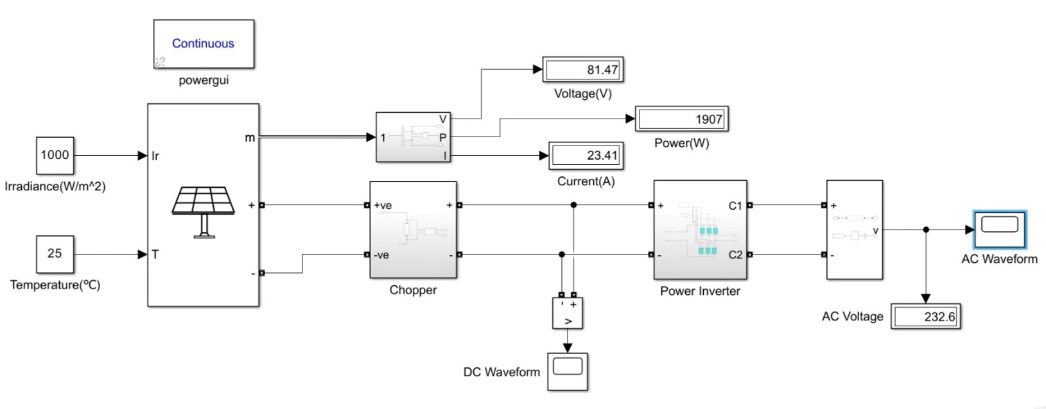

* POWER INVERTER:

* DC CHOPPER:

**6.WAVEFORMS**

1.BOOSTED DC WAVEFORM:

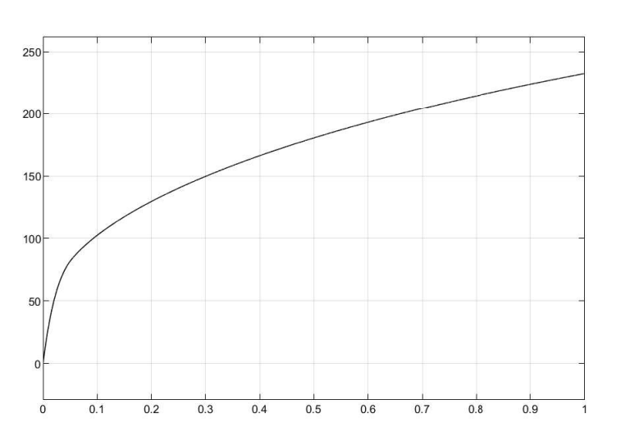

2.AC WAVEFORM:

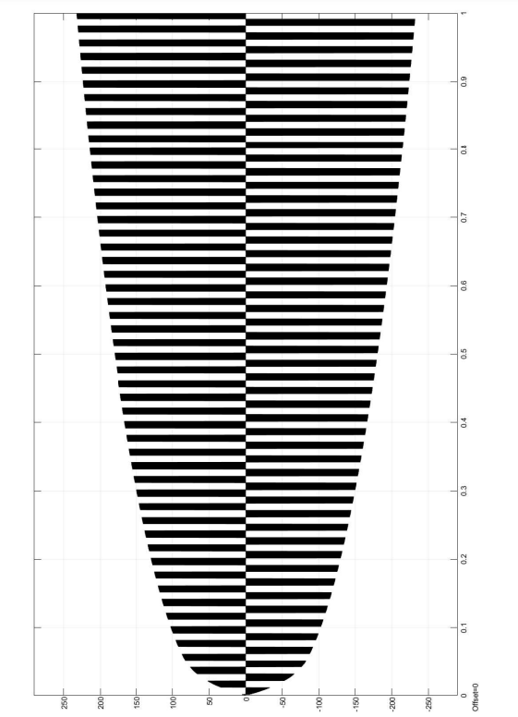

6.**Tools Used For Simulation**

1.PV ARRAY:

The PV Array block implements an array of photovoltaic (PV) modules. The array is built of strings of modules connected in parallel, each string consisting of modules connected in series. This block allows you to model preset PV modules from the National Renewable Energy Laboratory (NREL) System Advisor Model (2018) as well as PV modules that you define.

The PV Array block is a five-parameter model using a light-generated current source (IL), diode, series resistance (Rs), and shunt resistance (Rsh) to represent the irradiance- and temperature-dependent I-V characteristics of the modules .

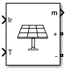

2.POWERGUI:

The powergui block allows you to choose one of these methods to solve your circuit:

* Continuous, which uses a variable-step solver from Simulink®
* Discretization of the electrical system for a solution at fixed time steps
* Continuous or discrete phasor solution

The powergui block also opens tools for steady-state and simulation results analysis and for advanced parameter design.

You need the powergui block to simulate any Simulink model containing Simscape™ Electrical™ Specialized Power Systems blocks. It stores the equivalent Simulink circuit that represents the state-space equations of the model.

powergui block

3.AC VOLTAGE:

The AC Voltage Source block implements an ideal AC voltage source. The generated voltage U is described by the following relationship:

*U*=*A*sin(*ωt*+*ϕ*),  *ω*=2*πf*,  *ϕ*=Phase in radians.

Negative values are allowed for amplitude and phase. A frequency of 0 and phase equal to 90 degrees specify a DC voltage source. Negative frequency is not allowed; otherwise the software signals an error, and the block displays a question mark in the block icon.

4.POWER INVERTER:

This example shows how to determine the efficiency of a single-stage solar inverter. The model simulates one complete AC cycle for a specified level of solar irradiance and corresponding optimal DC voltage and AC RMS current. Using the example model ee_solar_characteristics, the optimal values have been determined as 342V DC and 20.05A AC for an irradiance of 1000W/m^2 and panel temperature of 20 degrees Celsius. Inverter efficiency is determined in two independent ways. The first compares the ratio of AC power out to DC power in over one AC cycle. The second calculates losses by component by making use of Simscape™ logging. The small difference in calculated efficiency value is due to differences between trapezoidal integration used by the script and the greater accuracy achieved by the Simulink® variable-step solver .

**RESOURCES**

* Computer
* MATLAB

-Version -> R2023a

I. Simulink

II. Simscape

7.**CALCULATIONS**

1.DAILY ENERGY CONSUMPTION:

|  |  |  |  |  |  |
| --- | --- | --- | --- | --- | --- |
| **APPLIANCE** | **WATT(W)** | **NO.S** | **TOTAL WATTS**  **(W x No.)** | **NO. OF HOURS** | **ENERGY**  **(Wh)** |
| FAN | 33 | 1 | 33 | 6 | 198 |
| TUBELIGHT | 20 | 2 | 40 | 6 | 240 |
| TV | 100 | 1 | 120 | 6 | 600 |
| REFRIGERATOR | 150 | 1 | 200 | 6 | 900 |
|  |  |  | **TOTAL WATTAGE=426W** |  | **TOTAL ENERGY=1938Wh** |

**TYPES OF EARTHING**

1.Pipe earthing

Pipe earthing is a common method of connecting to the earth’s electrical conductors by using a steel pipe. Galvanized steel pipe with a diameter of 38 mm and a length of 2 meters is used as an earth electrode in pipe earthing by being laid vertically in the ground.

The amount of moisture In the soil and the strength of the current influence the size of the iron pipe that needs to be used. The soil’s moisture will determine the maximum depth at which the steel pipe may be installed.

The finest and most effective method of earthing is pipe earthing, which is also easily

2.Plate earthing

For this form of earthing, a plate composed of copper or galvanized iron is placed vertically in the ground pit less than three meters above the ground. For a more effective electrical grounding system, one must maintain the earth’s moisture condition surrounding the plate earthing system.

3.Strip/wire Earthing

In this form of earthing, strip electrodes with a minimum cross-sectional area of 6.0 mm2 and a minimum depth of 0.5 m are buried in horizontal trenches. If the electrodes are made of galvanized iron or steel, their cross-sectional area shall not be less than 25 mm x 1.6 mm.

When buried in the ground, a conductor with a minimum length of 15 m would provide enough earth resistance.

4.Rod Earthing

In this method of earthing, a copper rod with a galvanized steel pipe is placed vertically into the ground manually or with a hammer to the desired value; the lengths of the implanted electrodes reduce the earth’s resistance.

The rod used for this purpose is buried in the dirt at a certain depth, securely diverting the short-circuit electricity to the ground.This earthing technique is suitable for sandy areas and is also very budget-friendly.

**CONCLUSION**

We have studied the Solar Power System, it has provided a comprehensive overview of the solar power system, covering its introduction, types, construction, working, and market available sizes of solar panels. We have explored the grid-tied, off-grid, and hybrid solar power systems.

We have also analysed the construction process of the solar power system, including the components such as solar panels, inverter, and batteries. Additionally, we have explained the technical working of solar power systems, including the conversion of solar energy into electrical energy. We have also discussed the market available sizes of solar panels, their efficiency, and factors to consider when choosing solar panels. Through this, we have gained valuable insights into the benefits of solar power systems, including their cost savings, environmental impact, and reliability.

Additionally, the construction of solar panels involves the use of photovoltaic cells that convert sunlight into electricity. These cells are made from silicon and other materials and are arranged in modules to form solar panels. The efficiency of solar panels depends on various factors, including the type of cells used, their size, and the amount of sunlight they receive.

Furthermore, the market offers solar panels in various sizes, from small portable panels to large commercial-scale panels. The size of the solar panel required depends on the energy needs of the user and the available space for installation. Overall, the Solar Power System Review project has highlighted the importance and potential of solar power systems. As renewable energy sources become increasingly important, solar power systems will continue to play a crucial role in meeting our energy demands while protecting the environment.